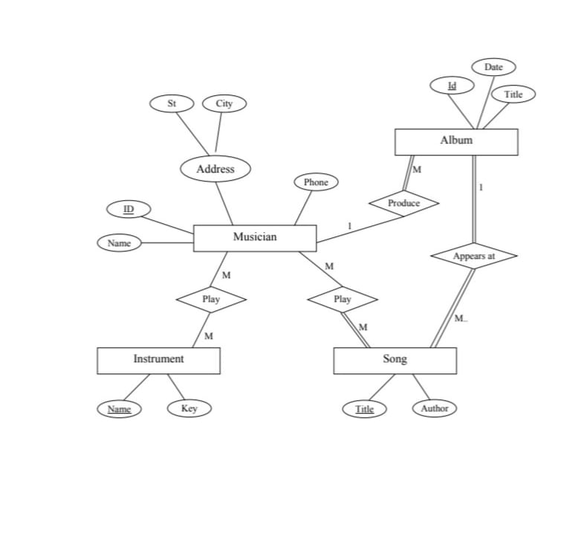

## 1. Entities and Attributes:

|  |  |
| --- | --- |
| Entity | Attributes |
| Musician | ID, Name, Phone, Address (St, City) |
| Instrument | Name, Key |
| Song | Title, Author |
| Album | ID, Title, Date |

## 2. Relationships and Cardinalities:

|  |  |  |
| --- | --- | --- |
| Entities | Relationship | cardinality |
| Musician - Instrument | Play | M : M |
| Musician - Song | Play | M : M |
| Song - Album | Appears at | M : 1 |
| Musician - Album | Produce | 1 : M |

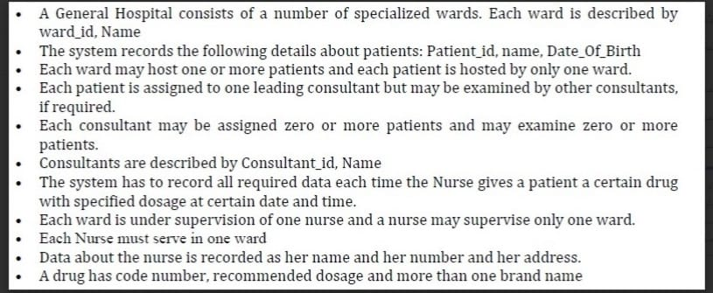

## 1. Entities and Attributes:

|  |  |
| --- | --- |
| Word | Word_ID , name |
| Patient | Patient_ID , name , date_of_birth |
| consultant | Consultant_ID , name |
| Nures | Nures_ID , name , address |
| Drug | Code_number , recommended_dosage , brand_names(multi-valued) |

## 2. Relationships and Cardinalities:

|  |  |  |
| --- | --- | --- |
| Entities | Relationship | cardinality |
| Hosts | Ward- patient | 1 : M |
| Assigned_to | Patient-consultant | M : 1 |
| examines | Consultant-Patient | M : M |
| supervises | Nurse -Word | 1 : 1 |
| Administers | Nurse-Patient-Drug | M : M |

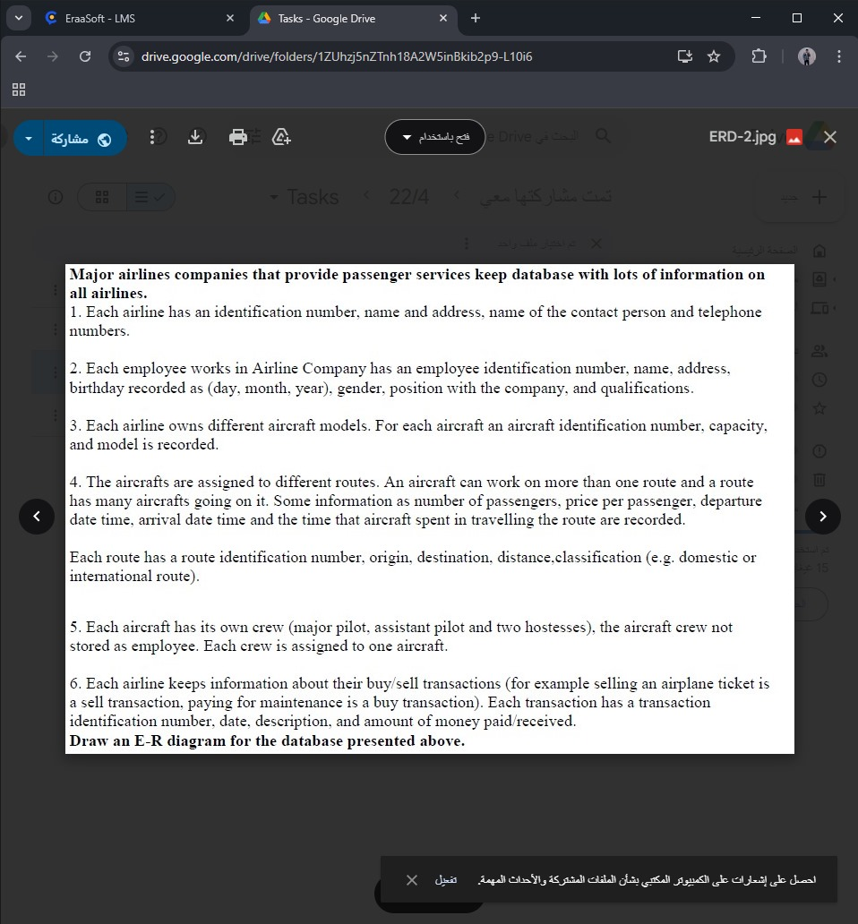

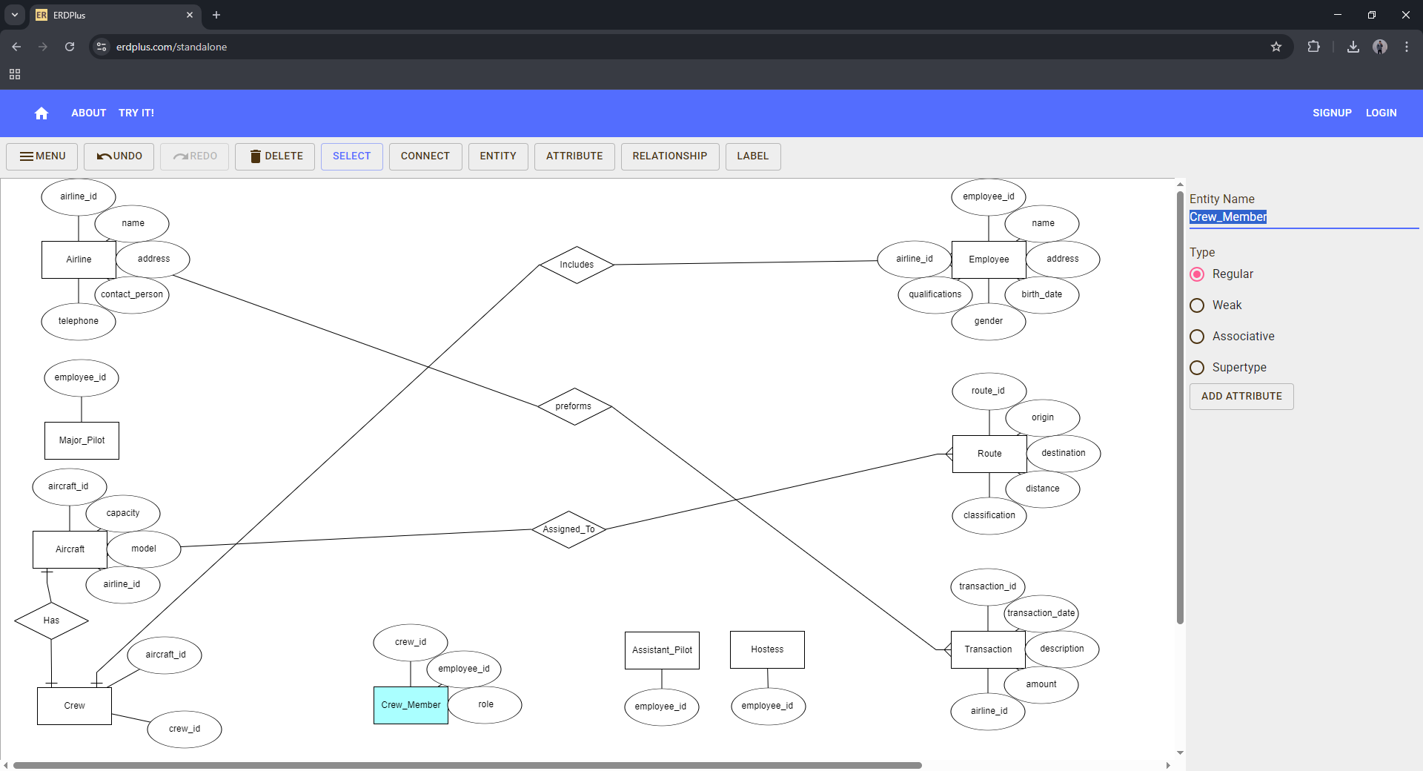

# 1. Entities and Attributes:

|  |  |
| --- | --- |
| Airline | airline_id, name, address, contact_person, telephone |
| Employee | employee_id , name, address, birth_date, gender, qualifications, airline_id |
| Major_Pilot | employee_id |
| Assistant_Pilot | employee_id |
| Hostess | employee_id |
| Aircraft | aircraft_id , capacity, model, airline_id |
| Route | route_id , origin, destination, distance, classification |
| Crew | crew_id , aircraft_id |
| Crew_Member | crew_id , employee_id , role |
| Transaction | transaction_id , transaction_date, description, amount, airline_id |

# 2. Relationships and Cardinalities:

|  |  |  |
| --- | --- | --- |
| Aircraft - Route | Assigned_To | M : M |
| Aircraft - Crew | Has | 1 : 1 |
| Crew - Employee | Includes | 1 : M |
| Patient - Consultant | Assigned_to | M : 1 |
| Consultant - Patient | Examines | M : M |
| Airline - Transaction | Performs | 1 : M |